Strength Training Impact on Patients Suffering from Acute and Chronic Stroke
Name:

University
Spring 2021
Professor:
Course:

Contents
Introduction 3
Literature Review 3
Stroke effect on muscle strength 5
Muscle strength deficit patterns 5
Muscle strength quantification in acute chronic stroke 6
Muscle Strength relevance in stroke patients 6
Safety and precautions 11
Appendix 14
References 22

Strength Training Impact on Patients Suffering from Acute and Chronic Stroke

Introduction
Strike refers to neurological loss which is caused by abnormal brain tissue perfusion. Acute chronic stroke is one among subarachnoid hemorrhages, ischemic, and intracerebral hemorrhages which affect. According to a current estimation, 3.45 million individuals who are aged 18 years, or more will have had a referral to a specialist of stroke by 2030. Such findings are cause for alarm, given that this condition has a weak prognosis, ranging from a significant deterioration in cognitive ability and cardiorespiratory health due to the core and periphery pathways to early succumb. Indeed, stroke was responsible for one in every twenty deaths in the United States in 2013, and anyone gets afflicted by this condition every minute. Hypertension inclusion numerous health issues for stroke have indeed been proposed, including diabetes mellitus, sleep apnea, atrial fibrillation, elevated triglycerides, an insufficient diet, tobacco consumption, and family history genetics, gender, physical inactivity, atherosclerosis, and chronic kidney disease. Admittedly, not only is lack of physical exercise correlated with the occurrence of most, if not all, of the above risk factors for stroke, but findings further show that relatively and extremely physically-exercise active people possess about 21% and 27.5% reduced risks of stroke complications respectively than the lowly-active people. Does strength training improve the health of acute and chronic stroke?

Literature Review
El-Nashar et al (2019) explain stroke as the leading cause of severe, lengthy dementia cases; the overall percentage of stroke victims is growing as a consequence of an aging population. Acute injury or stroke occurs when the brain tissue is cut off or when capillaries in the brain burst. The clinical effects of a stroke vary according to the anatomical brain areas involved and the extent of tissue injury. Acute stroke symptoms, in comparison to persistent musculoskeletal adaptations including contractures, lead to the accompanying weakening on the opposite side of the brain damage, referred to as hemiparesis.
Historically, resistance exercise has become problematic among individuals with spasticity. Patten et al (2004), argued that diminished muscle function was caused by the resistance of spastic opponents and that strenuous exercise increased spasticity and reinforced irregular movement. Thus, in contrast to comprehensive heart therapy and orthopedic programs, patients with stroke have typically engaged in mild fitness programs, with the majority of care focusing on inhibiting irregular muscle tone while facilitating regular activity habits. Stroke recovery, on the other hand, is now undertaking assumptions in light of new anatomical and clinical data. Sharp and Brouwer, for instance, discovered that persons who have suffered a stroke will undergo extensive muscle strengthening whilst not experiencing an uptick in spasticity, as assessed by the “leg pendulum test and synchronized EMG recordings”(Patten et al, 2004, p.6). Tested stretch reflexes of the ankle under within various artificial walking circumstances, and reported that gastrocnemius muscle spasticity is unlikely to result in the walking difficulties typical in acute and chronic stroke patients (Patten et al 2004, p. 6).
The growing understanding of the critical role of muscle strengthening in stroke rehabilitation is partly due to research demonstrating an association between muscle strength and the resulting impact on the victims who have had a stroke. Paretic muscle strength is associated with a variety of everyday life behaviors in stroke survivors, including hand-to-mouth communication, capacity to rise from a seat, stair ascending, coordination, and moving pace. Muscle function on the affected part of the body is often inversely linked to the duration of stay and decreases in inpatient stroke recovery. Additionally, significant associations occur among non-paretic Lower Extremity (commonly referred to as LE) muscle robustness, gait, and stair ascending tasks. Non-paretic limb deficiency has been recorded, implying that muscle power in all arms should be assumed. Even though association often does not mean causation, it does produce assumptions and ideas that can be evaluated in clinical studies (Gordon 2004).

Stroke effect on muscle strength

As contrasted to healthy adults, stroke results in a loss of muscle control on the paretic side and moderate fatigue on the ipsilateral, - the non-paretic part. N on-paretic complications are due to the limited proportion of cortical tracts descending that derive from the lesion site and persist ipsilaterally. According to Gordon (2004) sedentary behavior, which is frequently associated with stroke recovery, can often lead to the persistent stroke patient's decreased muscle intensity as opposed to stable maturity peers.

Muscle strength deficit patterns

According to the research by Eng et al, (2004) muscle power varies after a stroke is position- and volume-dependent, and also time-dependent. These factors can lead to differences in the extent to which the muscles are impaired following the stroke attack. While there exists no proof that either extensors or flexors are impaired predominantly after a stroke, there is empirical evidence to prove the finding that distal muscles on the paretic region possess larger power deficiencies than proximal tissues. This evidence corroborates findings in safe subjects that distal tissues are more easily facilitated by the corticospinal mechanism than proximal tissues. As a result, greater delays in distal muscles will indeed be anticipated following the disturbance of such pathways. The functional pairing of the cortical electroencephalogram is simply referred to as EEG, and the muscle electromyogram may be used to determine cortical regulation of muscle movement also known as EEG.
Following a stroke, distal upper extremity (UE) muscles ultimately exhibit decreased EEG-EMG cohesion, but not much more proximal tissues. This result is consistent with the observed increased core deficiencies in distal tissues. While Eng et al, (2004) historical study of medical history never confirmed such a proximal-distal trend in stroke victims, systematic reviews do. Muscle regeneration after stroke can often be affected by whether it occurs through the LE or UE. The severity of motor disabilities, as measured using the Fugl-Meyer scale, seems to be comparable between the LE UE and during the healing period of healing, but perhaps the UE seems to have a faster pace of motor recovery after hospital admission(Muir (2001)

Muscle strength quantification in acute chronic stroke

As striking as its occurrence can be, muscular fatigue is not felt by all stroke victims (Eng, 2004). Referring patients to suitable exercises Muscle strength measurement, which entails the use of physical force by the tester, has zero degrees of calibration. A secondary review of previously conducted shows a strong cap impact of hands-of-on analysis on muscle strength testing In grade 5/5 of the left knee extensor tear for 25 of the lateral meniscus, the average (expected) level of joint motion was 52.6% - 33.2% at medium joint range for orthopedic surgeons, 64.2 percent (41.5–86.5) at high joint range A dynamometer should not suffer from the above insensitivity. Measures of power can be achieved through using hand-grip, isokinetic dynamometers, and hand-held (Muir (2001)

Muscle Strength relevance in stroke patients

Nearly all physical activity can strengthen the muscles. Not every workout, though, will or can be classified as a reinforcing activity. Strength training, scientifically referred to as Progressive Resistance Training, is often a broad term that applies to all training which is associated with increasing the resistive loads, usually done at various advancing levels. At least 2 - 4 weeks, the training load is gradually raised to ensure an acute feedback mascle gain. Such resistive load has a favorable association with the extent of change. Such a model of training method has been extensively applied to older adults with impressive results in terms of power just as established by hypertrophy, functional mobility, and 1-RM.
Muscle power is statistically and statistically important in stroke cases. The scientific basis for the critical nature of muscle power following stroke is straightforward: force is equivalent to acceleration times mass which can be expressed mathematically as force = mass * acceleration. As result, muscle contraction is used to decelerate or accelerate body part entire body (setting body parts into motion). The rate of deceleration or acceleration will be affected by the levels to which stroke impacts the stresses that tissues will produce. Muscle power is significant to vary degrees based on the demands of the cognitive activities in which muscle power is needed.
The hypothetical association between intensity and success in practical tasks is depicted in the diagram below. Any task requires a specific level of power to complete. The quantity is determined by the action's requirement. Boosts in power, on the other hand, would be ineffective before a certain level is met. Following that, gains in intensity would be followed by improvements in efficiency at the functional exercise before no further strength is gained. Since operational tasks impose varying stresses on people, the threshold at which intensity starts to impair the operational activity success and the level at which extra strength becomes superfluous can differ considerably. As a result, a practical task such as taking food needs minimal power and can develop quickly with limited strength changes given enough hand dexterity is established.
Additional information by Gordon (2004) and Muir (2001) clearly illustrate that strengthening of shoulder and elbow muscles will be irrelevant for such a simple operation. Standing from a chair can be taxing. It requires considerable power, even with the support of the hands and a tool. Increased stamina enables the operation to be done without the aid of a tool or the forearms. Additional gains in power can enable it to be achieved more quickly. Nonetheless, there will come a time where increased power will no longer be synonymous with more activity development. Bolstering following this stage could be beneficial for developing a stable reserve, however, it will not increase current success at a functional operation.
The empirical basis of muscle power for acute stroke patients after stroke is provided by the studies demonstrating a correlation between physical activity muscle strength efficiency. Over 51 articles have identified such connections, with the majority focused on hind-limb behaviors. The practical movements that are often studied are sit-to-stand and ambulation, stand-pivot-sit transitions, and stair climbing, or curb ascending, as previously mentioned.
Different muscle fibers' power in the non-paretic and paretic forelimbs are strongly correlated with freedom in stand-pivot-sit transfer. The Independence during the stand-sit motion, the highly physically strenuous part of the move, is linked to the force applied by the muscle activation. This happens regardless of whether the hands are permitted during stand-sit motion. While the intensity of sides' knee extensors gets associated with stand-sit- freedom, the strongest associations typically occur when power sides' knee extensors become combined with the weight of the body. When these factors are combined, they account for approximately 68.5% and 70.5% of the difference in stand-sit freedom (Gambassi et al, 2017).
Strength of leg muscles correlates with a variety of measures of outpatient productivity following stroke, but perhaps the frequently examined correlation is with gait speed. The researchers are compatible in showing strong bivariate correlations between the limb muscles, Even so, bivariate associations are not often observed. The findings of studies that have investigated the quantitative correlation between lower limb intensity, non-strength parameters, and gait efficiency attest to the predictive power of tissues, especially the power of the lower paretic limb.
Just two experiments investigated the association between lower limb intensity and stair ascending success in acute and chronic stroke. Both studies discovered substantial associations (58% – 85%) regarding paretic limb intensity and stair climbing efficiency (12.5, 18.5). The analysis found no important associations between stair ascending velocity and intensity measurements from the lower non-paretic limb (–0.07–0.08).
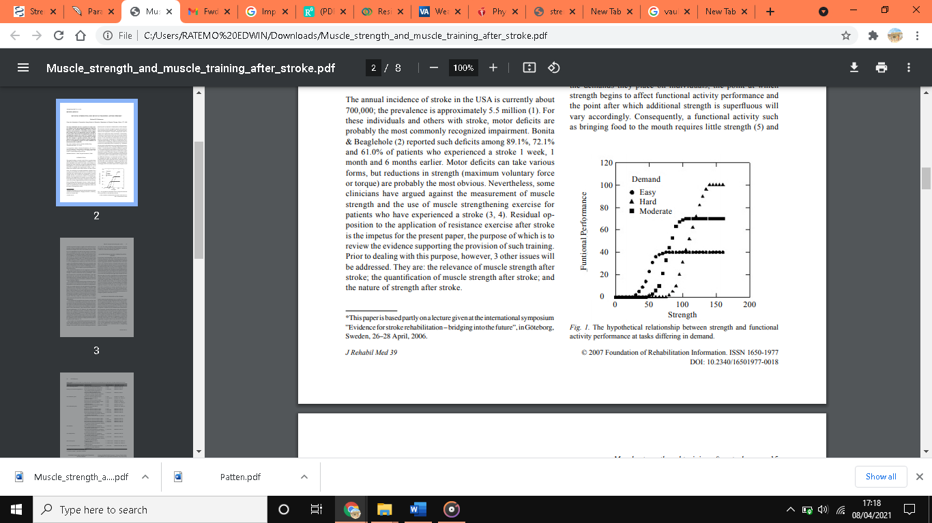
Figure 1: Bohannon et al, (2007), Relationship between functional workout and strength
However, several others also argued that the strengthening programs that work on those who have had a stroke in the past are successful, based on both realistic and mathematical expectations, it's predicted that practical behaviors can be improved by workouts.
Nonetheless, Bohannon, (2007, p. 4) “the performance of functional activities or participation in societal roles remains unknown” it is not certain to produce results. Data showed no clear impact of strength exercise on recovery of control following stroke. According to the new analysis, it is worthwhile, except maybe on a case-by-by-case basis. Such moves were found to be effective in all 3 separate research studies. This may have anything to do with the idea of learning just for the sake of targeting a certain outcome. Hand- and sit-to-to-stand and other similar movements, including getting out of bed when in a horizontal, are easy to do almost everywhere, as long as you don't need any equipment. Improved motor ability in older adults with and no prior history of stroke was observed. Those such as flexing the knee and resisting with weight stacks like isokinetically are hardly practical or versatile.
Regardless of the method of strength training, you can do more intense movements. Deficits may affect the limbs other than the paretic ones. Measuristics that are often applied may not be needed to get the goals, they may only be appropriate to separate the wheat from the chaff. Sufficient extant study has sought outpatients of various ages and abilities. More testing is needed to identify which categories of students profit from particular treatments. It is therefore important to investigate whether the preparation gains generalize to other behaviors not directly, but to anything that may have been done to promote such activities. Before more studies are done, positive evidence can guide our encouragement in the usage of aerobic exercise during a stroke.
Researcher | Sample | Intervention | Period | Outcome
Moreland et al, (2003) | 33 patients | Resistive exercise  Resistive workouts | 30 min for two weeks | No difference
Patten et al, (2004) | 77 patients | Active activities  Functional training  Resistive exercises | 1-2 months | Significant improvement
Ada et al, (2006) | 20 patients | Hip flexion  LE isokinetic | 5 weeks | No changes
Bohannon, (2007) | 53 | Rehabilitation  Leg extensor |  | LE power increment by 32 %
Gambassi et al, (2017) | 20 ambulatory | Passive workouts  knee, hip, and ankle strengthening | 6 weeks | 56% UE increase and 56% LE isometry force
Eng et al, (2004), | 7 | Isokinetic paretic knee | 12 weeks | 21 % paretic knee extension
Table 1: Research summary Eng (2004).

Safety and precautions

From the research by Eng et al, (2004), exercise medication has to take into account elevated blood pressure and cardiovascular issues, since 75% of those with stroke and 70% of those with high blood pressure experience heart challenges. Intense physical activity has shown very strong Blood Pressure responses. For instance, a 30-second linear two-leg extension at 87% of extreme pressures will increase the systolic/diastolic levels to approximately 283 mm Hg and the pulmonary pressures to 182 mm Hg in healthy people.
Eng et al.'s (2004) findings are synonymous with Ada et al, (2006) research outcome; one may ask that for persons who have had a trauma, what level of pressure is needed to achieve muscle-strengthening results? An adequate amount of research on working out at elevated levels of difficulty for people with stroke has explored these strategies. BP in the manometer revealed that an increase in pressure of 81% can't be avoided in persons using a leg push. A study showed a 31%–50% or more increase in UE and LE power after doing a strengthening of low-intensity regimen (31–50MVC) among stroke patients Nevertheless, in this analysis, the control group was missing: of those not exposed to the stimulus. Submaximal training protocols can be studied to see if they are useful in becoming stronger in people with stroke. Individuals with stroke may derive benefits from fitness programs of different intensity as well as others that are stable.
There will be some alterations and substitutions applied to minimize side effects. Any research shows that a cool-down and warm-up exercise routine will help people keep their BP stable. When you do exercises where your body is required to be in an upright position, your blood pressure can rise less than when you lie on a reclining. One should take preventive measures to escape Valves: Using lower and breath-holding intensity techniques can assist in reducing the use of the Valsalva maneuver.
Physiologic reactions may be influenced by muscle contractions, such as arterial dilation or constriction. Moreover, at 71% or 89 % of full voluntary contraction, imply that BP is at its lowest, and this implies that its absolute force is zero, whereas eccentric contractions and isometric are of equal force. As well, eccentric training is less stressful to the greater the lower the forces used to reach a given performance. When bed rest, inactivity, and muscular fatigue are normal during a stroke, one might be more likely to get hurt in vigorous exercise.
It has been observed in research through electron microscopy that stiff opposition exercise does more harm to older individuals compared to young people. This is more probable that muscle pulls or tears will develop when you are not working out while you are doing an eccentric workout, which may become more complicated when you get out of a long period of inactivity. It has been found muscle strain can develop injury after introducing mild aerobic exercise in the weight-bearing arm in the non-limb in adult individuals than children after the same period. Despite its stronger likelihood of producing musculoskeletal strain, eccentric activity is less taxing on the heart muscle. Therefore, a simple, progressive workout program reduces the likelihood of muscle strain and injuries. Based on behavioral reactions to people that are well, these safety rules are never sufficient for patients with stroke. Clinical experiments must have both anatomical and clinical tests if they are to prove the benefits of muscle strengthening treatments(Signal et al, 2014).
So far Veldema and Jansen (2020) have illustrated that strength exercise can increase muscle fitness, but the results must be corroborated to see if it influences everyday activities. The optimization of strength workouts in individuals with stroke remains a major area of investigation, especially regarding ideal training intensities, the interplay with other rehabilitative therapies, and whether they have a positive impact on bone strengthening, and the different forms of muscle contractions.

Appendix 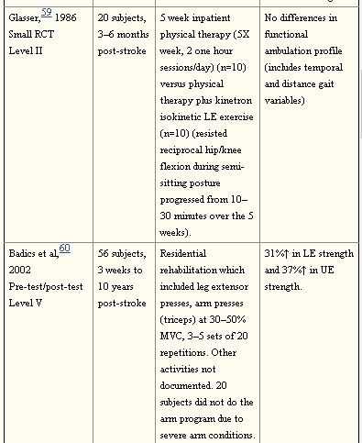
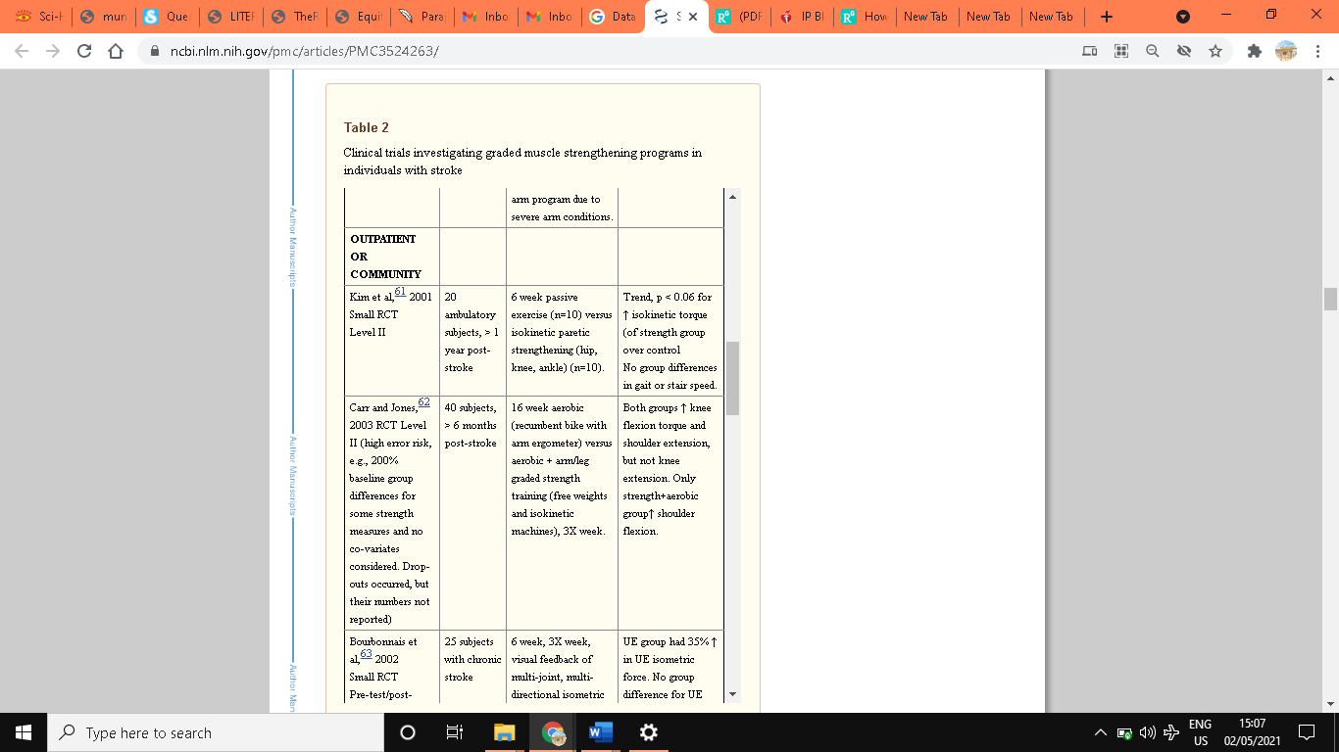
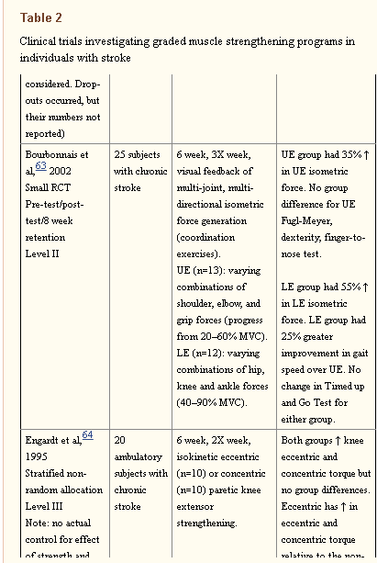

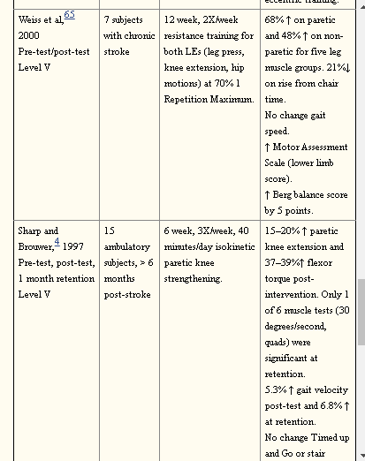
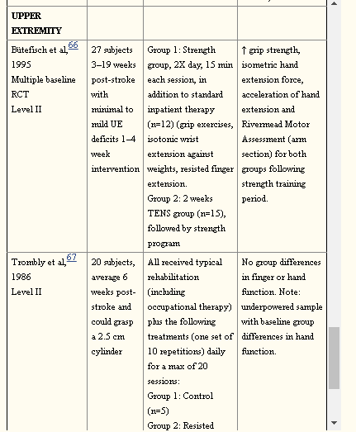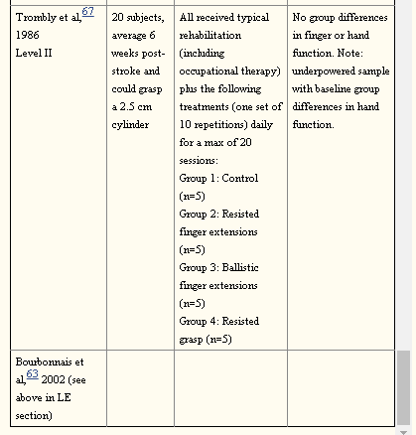

References
Ada, L., Dorsch, S., & Canning, C. G. (2006). Strengthening interventions increase strength and improve activity after stroke: a systematic review. Australian Journal of Physiotherapy, 52(4), 241-248.
Bohannon, R. W. (2007). Muscle strength and muscle training after stroke. Journal of rehabilitation Medicine, 39(1), 14-20.
El-Nashar, H., ElWishy, A., Helmy, H., & El-Rwainy, R. (2019). Do core stability exercises improve upper limb function in chronic stroke patients?. The Egyptian Journal of Neurology, Psychiatry and Neurosurgery, 55(1), 1-9.
Eng, J. J. (2004). Strength training in individuals with stroke. Physiotherapy Canada. Physiotherapie Canada, 56(4), 189.
Gambassi, B. B., Coelho-Junior, H. J., Schwingel, P. A., Almeida, F. D. J. F., Gaspar Novais, T. M., Lauande Oliveira, P. D. L., ... & Rodrigues, B. (2017). Resistance training and stroke: a critical analysis of different training programs. Stroke research and treatment, 2017.
Gordon, N. F., Gulanick, M., Costa, F., Fletcher, G., Franklin, B. A., Roth, E. J., & Shephard, T. (2004). Physical activity and exercise recommendations for stroke survivors: an American Heart Association scientific statement from the Council on Clinical Cardiology, Subcommittee on Exercise, Cardiac Rehabilitation, and Prevention; the Council on Cardiovascular Nursing; the Council on Nutrition, Physical Activity, and Metabolism; and the Stroke Council. Circulation, 109(16), 2031-2041.
Muir, K. W. (2001). Medical management of stroke. Journal of Neurology, Neurosurgery & Psychiatry, 70(suppl 1), i12-i16.
Patten, C., Lexell, J., & Brown, H. E. (2004). Weakness and strength training in persons with poststroke hemiplegia: rationale, method, and efficacy. Journal of Rehabilitation Research & Development, 41.
Signal, N. E. (2014). Strength training after stroke: Rationale, evidence and potential implementation barriers for physiotherapists. New Zealand Journal of Physiotherapy, 42(2).
Veldema, J., & Jansen, P. (2020). Resistance training in stroke rehabilitation: systematic review and meta-analysis. Clinical Rehabilitation, 34(9), 1173-1197.

